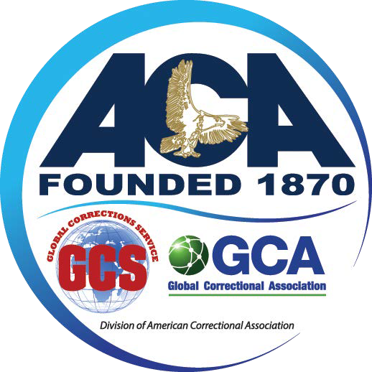
American Correctional Association

CALL FOR PROPOSALS

The American Correctional Association is excitedly preparing for its 154th Congress of Correction.
The Congress will be held in Nashville, Tennessee, and will occur Thursday, August 15th through Sunday, August 18th, 2024.

ACA has a rich history of providing quality, professional development opportunities for its membership. Corrections professionals and practitioners are invited to contribute to the professional development of ACA’s members by sharing their expertise with ACA’s national and international conference attendees.

We are seeking:

- Workshops that examine contemporary issues relevant to correctional staff and/or the corrections field.
- Presenters that present practical and evidence-based information that exhibits relevance to cross sections in the corrections field.
- Diverse presentations that are engaging, credible, and reflect proven success in the corrections field generally or to a specific subset of the corrections community (juveniles, community corrections, prisons, jails).

Submission Deadline: Friday, March 29, 2024

For questions, contact ACA:

Office of Professional Development & Engagement
acaprodev@aca.org
(703) 224-0000 Option 6

SUBMISSION REQUIREMENTS:
Please follow the instructions below and complete the current proposal application (visit www.aca.org > Conferences >Workshops and Training> Submit a workshop Proposal).

Workshop proposals must be submitted to ACA’s Office of Professional Development & Engagement at education@aca.org by March 29, 2024 for review and approval.

Submissions MUST include:

- Fully completed workshop proposal application to include:
  - Workshop Title
  - Workshop Abstract
  - 3-4 Learning Objectives
  - 1 Primary Point of Contact (for workshop-related communication with ACA regarding the workshop submission)
  - 1 Moderator
  - 2-3 Presenters
(The minimum number of presenters required is 2; the maximum number of presenters is 3. At least 1 presenter must be a current practitioner in the field.
ACA reserves the right to permit single presenters. Single presenters are a rare opportunity and may be considered by ACA on a case-by-case basis.)
- Membership Numbers for the moderator and each presenter
(All moderators and presenters must be current ACA members)

- Resume, Bio, and Disclosure Form for the moderator and each speaker.
Bio Format:

- Name, State; Current Title; Place of Employment
- Synopsis of employment history
- Description of educational background
- Other professional affiliations or awards
- Prior service on ACA committees
- Additional brief comments, and a synopsis of qualifications as it pertains to serving as a moderator or presenter.

NOTE: For review and approval, all submissions MUST include the requested information.
Failure to submit a completed application packet (including resumes, bios, disclosure forms for presenters and moderators) will result in a delay of review and approval.
Upon workshop approval, all important deadline dates and submission resources (including PowerPoint/Workshop Outline presentation deadlines and the ACA PowerPoint template) will be provided. Note: If a PowerPoint will not be used, then a complete Workshop Outline must be submitted for review and approval.

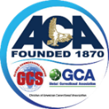

American Correctional Association

154TH Congress of Corrections

WORKSHOP PROPOSAL APPLICATION
Submission Deadline: Friday, March 29, 2024

WORKSHOP TITLE
(Limited to 150 characters. Do not use abbreviations.)
PRIMARY AREA OF FOCUS
(What is the primary topic for the workshop? Select one.)
□ Safety and Security □ Reentry
□ Career Planning □ Sustainability
□ Leadership/Professional Development □ Healthcare/Wellness
□ Facility Design & Infrastructure □ Correctional Education
□ Workforce Management & Culture □ Special Populations
PRIMARY COMMUNITY OF FOCUS
(For which correctional setting is your workshop focused on? Select one.)
□ Adult Corrections □ Juvenile
□ Community Corrections □ Prisons
□ Jails □ Prisons & Jails
PRIMARY POINT OF CONTACT
(Who is the individual ACA should contact for questions regarding this proposal submission?)
NAME:
EMAIL ADDRESS:
DAYTIME TELEPHONE NUMBER:
ACA MEMBER ID NUMBER:

ABSTRACT
(Limited to 750 characters, including spaces. Do not use abbreviations.)

What is the purpose and general overview of your presentation? Summarize the major points of your abstract and describe how this topic will advance either the practice/professional development of the participant or the field of correction.
REFERENCES
(A minimum of 2 references is required. The topic must demonstrate consistency with available literature and evidence. References to literature should be formatted using APA style. All references to journal articles should include the DOI (digital object identifier).
Reference 1:
Reference 2:

LEARNING OBJECTIVES
(Identify the 3 primary objectives of your workshop presentation. Be specific and thoroughly complete the statement.)
Objective #1
At the conclusion of this session, participants will be able to….

Objective #2
At the conclusion of this session, participants will be able to….

Objective #3
At the conclusion of this session, participants will be able to….

FACILTATOR INFORMATION
(Upon approval of the workshop proposal, the information provided will be utilized as submitted for conference-related materials and publications.)
MODERATOR
**Must be an ACA member. A resume, bio, and Disclosure Form for the moderator must be submitted with the application.
Name:
Title:
Agency:
City & State:
ACA Member ID #:
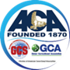
PRESENTERS
**Each presenter must be an ACA member and a resume, bio, and Disclosure Form for each presenter must be submitted with the application.

(Designate one presenter as the primary presenter. A minimum of 2 presenters is required; there is a maximum of 3 presenters permitted. One speaker MUST be a practitioner in the field, Presenters will be listed in materials and publications in the order listed.)
PRIMARY PRESENTER
The only person to whom ACA will send subsequent communication regarding acceptance of the proposal and onsite logistics.
Name:
Title:
Agency/Employer:
City & State:
ACA Member ID #:
Email Address:
Daytime Telephone Number:
ADDITIONAL PRESENTER 1:
Name:
Title:
Agency/Employer:
City & State:
ADDITIONAL PRESENTER 2:
Name:
Title:
Agency/Employer:
City & State:
ACA Member ID #:
PREFERRED ACCOMMODATIONS
Presentation Day
ACA attempts to schedule workshops in accordance with the conference schedule’s space availability and the presenters’ availability. Please identify the conference day(s) your team can commit to being available to present.
□ Thursday □ Friday □ Saturday □ Sunday
Audiovisual Needs
Each presentation room will be preset with the following equipment:

- 1-Laptop with Microsoft Office, audio, and audio amplified to audience
- 1-Handheld wireless podium microphone
- 1-Wired floor microphone
- 1-Wired head table microphone
- 1-LCD projector and screen

Identify any additional equipment needs below.
Additional Equipment:

Additional Requests
ACA will do its best to accommodate special requests, including for room setups. However, the ability to do so is very limited and not guaranteed.
Please specify any special requests below.
Special Request:

Submission Instructions
Please submit your outline by either attaching it to this PDF document or through email.
To attach a document to a PDF, click on the expanding arrow on the left side of the document if it is not already expanded. Click on the paperclip icon. From there, you can drag and drop the document you wish to attach.
To email your document, please attach it to an email with the subject line “Workshop outline submission” and send to education@aca.org

Please review the following, and provide your signature to acknowledge your agreement and acceptance of the following guidelines for workshop presentations:

CHANGES

Once a proposal is accepted as a session, all changes to the proposal must be submitted by set deadlines.

SCHEDULE
ACA reserves the right to assign the day and time that accepted proposals will be scheduled.

STATUS UPDATES
Status updates will be sent by e-mail regarding acceptance of proposals to the primary presenter. Invitations to present not acknowledged by the due date will result in a session being dropped from the conference itinerary.

REGISTRATION
All speakers whose proposals are accepted for presentation must register for the conference at least 60 days ahead of the first day of conference. ACA does not cover the costs associated with membership, registration, and attendance for the conference.

RIGHT TO PUBLISH
ACA reserves the right to publish any submission, in whole or in part, in any form by any printed, visual, electronic, or auditory means.

By checking this box, I give ACA, American Correctional Association, permission to upload all the audio/visual functions that will be used during the workshop. This information will be streamed to ACA’s virtual platform and displayed on ACA’s social networking pages and website.

PROMOTION IS STRICTLY PROHIBITED
The exclusive promotion or sale of goods, services, or products during educational sessions at conferences is prohibited. Speakers who are found to be engaging in such practices will have their sessions halted.

I, along with my team of presenters and moderator, have read and understand the ACA guidelines for workshop presentation. My signature below indicates our acceptance of the guidelines and commitment to adhere to the guidelines upon acceptance of the workshop proposal.

_____________________________________________________ _______________________
PRINTED NAME DATE

SIGNATURE

